Math 1 Name_________________________

**5-4 Midpoint and Distance Formula** Date________

* *I can find the distance between two points.*
* *I can find the midpoint of a line segment.*

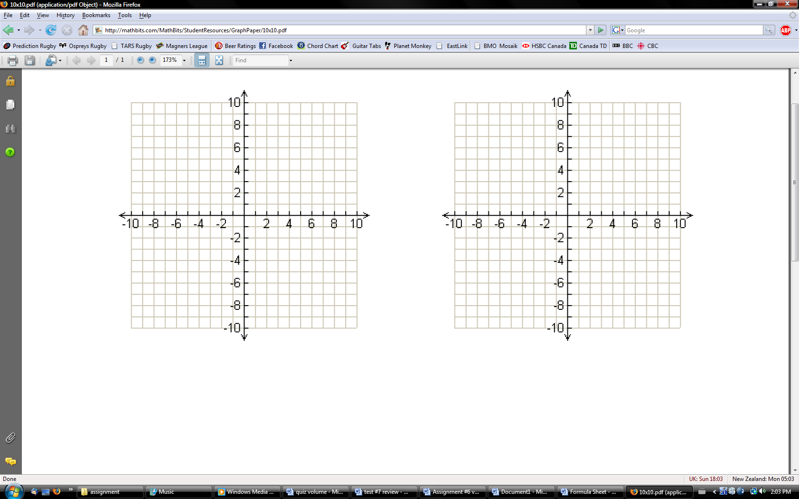

Part 1: Graphing

1. Graph the points A (1, 6) and B (9, 6).  Find the midpoint of http://faculty.necc.mass.edu/mast/modules/pendergast/MidpointWorksheet_files/image002.gif. Find the distance of http://faculty.necc.mass.edu/mast/modules/pendergast/MidpointWorksheet_files/image002.gif.



2. Graph the points E (-10, -9) and F (-10, -3).  Find the midpoint of http://faculty.necc.mass.edu/mast/modules/pendergast/MidpointWorksheet_files/image006.gif. Find the distancehttp://faculty.necc.mass.edu/mast/modules/pendergast/MidpointWorksheet_files/image006.gif.



3. Graph the points C (2, 2) and D (6, 5).  Find the midpoint of http://faculty.necc.mass.edu/mast/modules/pendergast/MidpointWorksheet_files/image004.gif. Find the distance of http://faculty.necc.mass.edu/mast/modules/pendergast/MidpointWorksheet_files/image004.gif.

**Notes:**

Part 2: Finding Midpoint

***Find the midpoint for each line segment using the formula (no graphing needed). Show the formula and all work.***

  4. G (6, 5) and H (9, 2)

 5. I (1, 1) and J (-3, -3)

6. K (1, -1) and L (8, -7)

Part 3: Finding Distance

Find the distance between each set of points. Show work.

7. (0, 0) and (4, 3)

8. (3, -3) and (2, 7)

9. Determine the coordinates of the points needed. Then find the distance of each line segment.

a) GH G ( , ) H ( , )

b) KL K ( , ) L ( , )

Part 4: Putting it All Together

10. Triangle ABC has coordinates A (3, 9), B (5,1) and C (9, 5). **D is the midpoint of AB** and **E is the midpoint of AC**.

* 1. Graph the points A, B, and C (make sure you label them). Find the coordinates of points D and E. Show all work.

D =

E =

* 1. Plot points D and point E on the graph and label.
  2. Find the **length of DE**. Show all work.